**Multi Attach:**

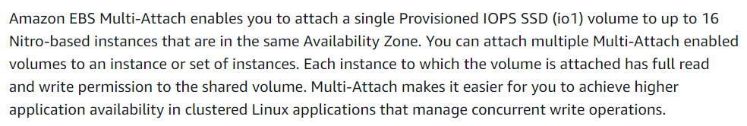

* Multi-Attach enabled volumes can be managed in much the same way that you would manage any other Amazon EBS volume. However, in order to use the Multi-Attach functionality, you must enable it for the volume. When you create a new volume, Multi-Attach is disabled by default.

**Limitations:**

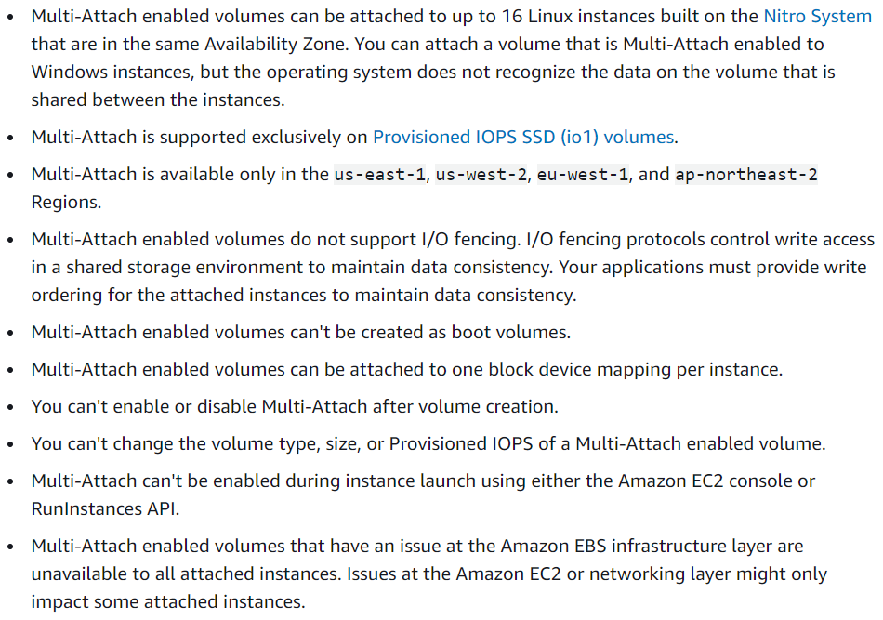

**Performance:**

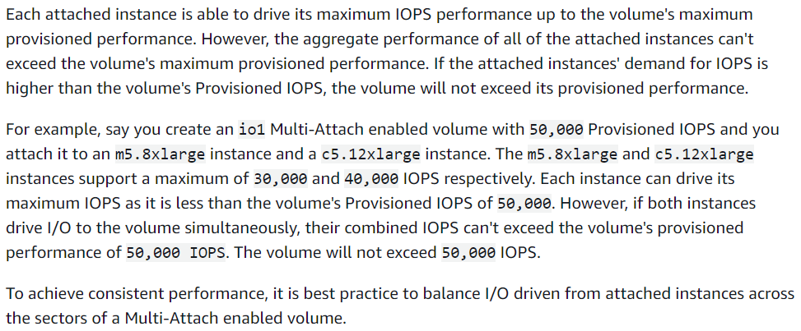

**Enabling multi attach:**

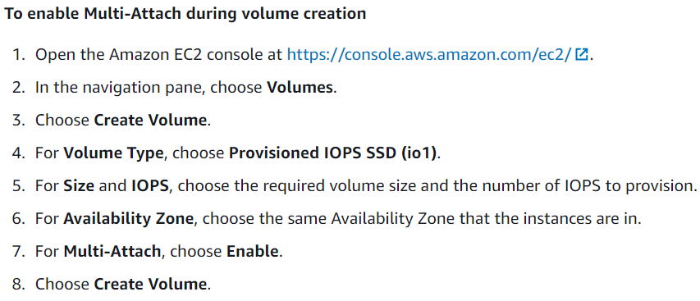

**Deleting on termination:**

